Virtual Eye

Novelty:

# It is designed to overcome the lack of visual sense, by using other senses like sound and touch. It uses audio and vibration signals to notify the user about upcoming hurdle.

Python programming language is used for developing the AI virtual mouse system, and also, OpenCV which is the library for computer vision is used in the AI virtual mouse system. In the proposed AI virtual mouse system, the model makes use of the MediaPipe package for the tracking of the hands and for tracking of the tip of the hands, and also, Pynput, Autopy, and PyAutoGUI packages were used for moving around the window screen of the computer for performing functions such as left click, right click, and scrolling functions. The results of the proposed model showed very high accuracy level, and the proposed model can work very well in real-world application with the use of a CPU without the use of a GPU.

Feasibility of Idea:

Several lives are lost every year due to drowning on the beaches and other water bodies all over the world, representing a tragic loss to the family members as well as the nation. To save the lives of drowning victims, we have developed a low-cost drone for assisting the lifeguard, in search and rescue operations, for the coastal beaches of the state of Goa, India. The lifeguard on the control tower of a beach will deploy the drone towards the victim in distress in the water. A floatation device is deployed near the drowning victim. The person in distress can hold onto the flotation device till the lifeguards can approach the spot and perform a rescue operation. The use of the drone can also be extended to rivers, lakes and popular picnic as well as religious pilgrimage sites, where several members of the public congregate, to monitor and perform rescue operations. A proof-of-concept prototype of the lifeguard assist drone has been developed. A floatation device deployment mechanism has been designed and deployed on the lifeguard assist drone. Initial trials have provided excellent results and the cost of the system is much lesser than similar systems in idea.

Algorithm 1 Lifeguard drone deployment opera

1: Lifeguard is informed about the area where the victim in

distress is lo

## At the start of 2021 Bybadet in Ålesund, Norway was opened to the public. Pool safety is a top priority at the facility and SwimEye was chosen to aid in preventing drowning accidents. SwimEye is now monitoring four separate pools at Bybadet. We really feel that...

SwimEye develops, manufactures and retails rapid alerts for life-saving situations. Our core product is the SwimEye Computer Vision Detection System. SwimEye works as an “extra lifeguard” in your swimming pool. We supply and service all international markets, operating from our home in Stavanger, Norway.

Business model:

Imagine the following scenario: You have a brilliant idea for a new AI project. To make it happen, you need to convince management to fund your idea. You need to pitch your AI project idea to stakeholders and management. Yuck.

This is the first step where the AI Project Canvas comes into play. Although Louis Dorard has already created the [ML Canvas](http://www.louisdorard.com/machine-learning-canvas/), the AI Project Canvas focuses on explaining the business value of your AI project. The AI Project Canvas helps you to structure and convey the holistic idea of your AI project to others.

The right part of the AI Project Canvas covers the integration of your project into the current infrastructure, for stakeholders and the customer.

AI products rarely live in an isolated world, hardly ever in a Jupyter Notebook. They always have to be integrated into an existing architecture. Explain where and how the project will be used. Where does it fit into the backend? How will the customer engage with your model? Will you use a microservice, monolith, or predict on-the-fly during streaming? Answering these questions will make it clear how the project will be brought into production.

Listing the Key Stakeholders will give you an overview of important decision makers. Key Stakeholders can be internal departments like legal, UX, management or even external stakeholders like contractors, owners, political or non-profit groups.

The right-most block is the second most important block after the Value Proposition. Who is the Customer that you are designing the project for? Too often, Data Scientists fall in love with technical details of their model but lose track of who they are developing the model for. Does the customer really care about an accuracy improvement from 99.2% to 99.3% or would faster inference time suit them better? Write in detail about your different customer groups to guide your decision-making throughout the process.

After defining how to bring the project to the Customer, let’s finally explore the Financial requirements of your AI project.

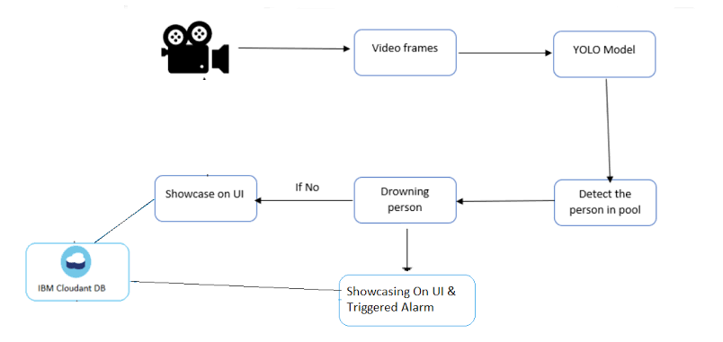

Social impact:

Real-life examples of AI are already being applied in about one-third of these use cases, albeit in relatively small tests. They range from diagnosing cancer to helping blind people navigate their surroundings, identifying victims of online sexual exploitation, and aiding disaster-relief efforts (such as the flooding that followed Hurricane Harvey in 2017). AI is only part of a much broader tool kit of measures that can be used to tackle societal issues, however. For now, issues such as data accessibility and shortages of AI talent constrain its application for social good.

This article is a condensed version of our discussion paper, [*Notes from the AI frontier: Applying AI for social good*](https://www.mckinsey.com/~/media/mckinsey/featured%20insights/artificial%20intelligence/applying%20artificial%20intelligence%20for%20social%20good/mgi-applying-ai-for-social-good-discussion-paper-dec-2018.pdf) (PDF–3MB). It looks at domains of social good where AI could be applied, and the most pertinent types of AI capabilities, as well as the bottlenecks and risks that must be overcome and mitigated if AI is to scale up and realize its full potential for social impact. The article is divided into five sections:

1. [Mapping AI use cases to domains of social good](https://www.mckinsey.com/featured-insights/artificial-intelligence/1#part)
2. [AI capabilities that can be used for social good](https://www.mckinsey.com/featured-insights/artificial-intelligence/2#part)
3. [Overcoming bottlenecks, especially around data and talent](https://www.mckinsey.com/featured-insights/artificial-intelligence/3#part)
4. [Risks to be managed](https://www.mckinsey.com/featured-insights/artificial-intelligence/4#part)
5. [Scaling up the use of AI for social good](https://www.mckinsey.com/featured-insights/artificial-intelligence/5#part)

For the purposes of this research, we defined AI as deep learning. We grouped use cases into ten social-impact domains based on taxonomies in use among social-sector organizations, such as the AI for Good Foundation and the World Bank. Each use case highlights a type of meaningful problem that can be solved by one or more AI capability. The cost of human suffering, and the value of alleviating it, are impossible to gauge and compare. Nonetheless, employing usage frequency as a proxy, we measure the potential impact of different AI capabilities.

For about one-third of the use cases in our library, we identified an actual AI deployment (Exhibit 1). Since many of these solutions are small test cases to determine feasibility, their functionality and scope of deployment often suggest that additional potential could be captured. For three-quarters of our use cases, we have seen solutions deployed that use some level of advanced analytics; most of these use cases, although not all, would further benefit from the use of [AI techniques](https://www.mckinsey.com/featured-insights/artificial-intelligence/visualizing-the-uses-and-potential-impact-of-ai-and-other-analytics). Our library is not exhaustive and continues to evolve, along with the capabilities of AI.

### **Crisis response**

These are specific crisis-related challenges, such as responses to natural and human-made disasters in search and rescue missions, as well as the outbreak of disease. Examples include using AI on satellite data to map and predict the progression of wildfires and thereby optimize the response of firefighters. Drones with AI capabilities can also be used to find missing persons in wilderness areas.

### **Economic empowerment**

With an emphasis on currently vulnerable populations, these domains involve opening access to economic resources and opportunities, including jobs, the development of skills, and market information. For example, AI can be used to detect plant damage early through low-altitude sensors, including smartphones and drones, to improve yields for small farms.

### **Educational challenges**

These include maximizing student achievement and improving teachers’ productivity. For example, adaptive-learning technology could base recommended content to students on past success and engagement with the material.

### **Environmental challenges**

Sustaining biodiversity and combating the depletion of natural resources, pollution, and climate change are challenges in this domain. (See Exhibit 2 for an illustration on how AI can be used to catch wildlife poachers.) The [Rainforest Connection](https://rfcx.org/home), a Bay Area nonprofit, uses AI tools such as Google’s TensorFlow in conservancy efforts across the world. Its platform can detect illegal logging in vulnerable forest areas by analyzing audio-sensor data.

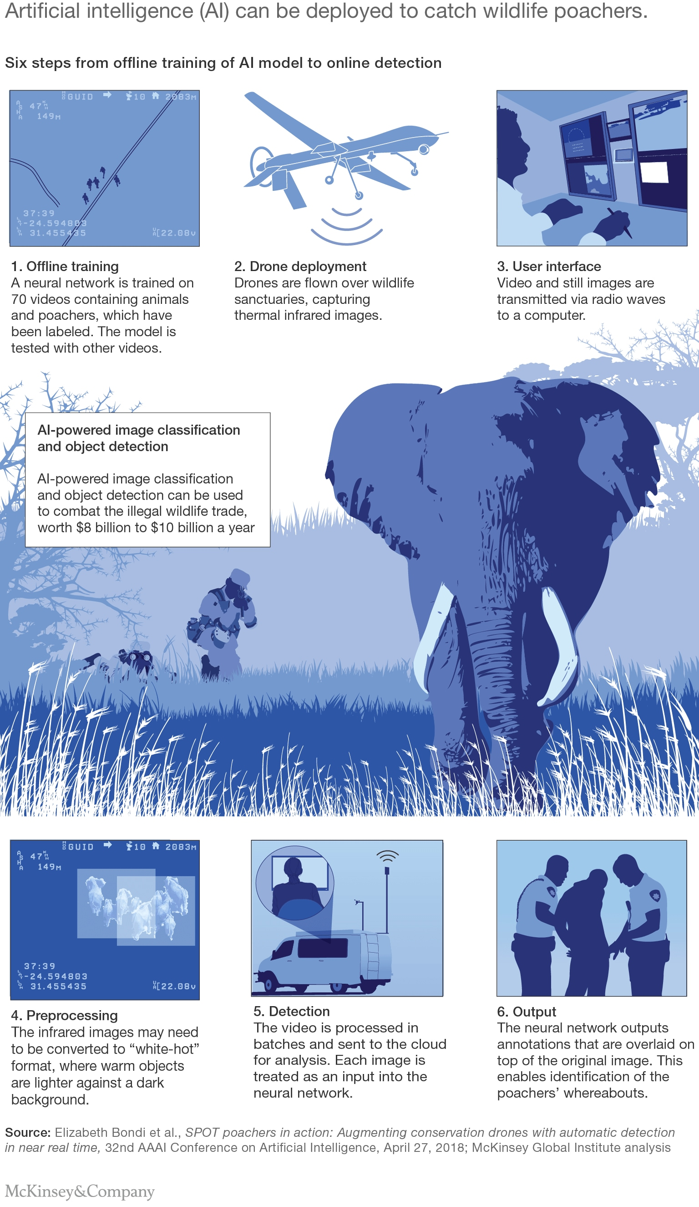

Scalability of solutions:

Similarly to software development, it’s easy to build an ML model that works for you and your team, but it can be extremely complicated when you need the model to work for people across the world. Nowadays, data teams are expected to build scalable applications that work for millions of **users,**residing in millions of **locations,**at a reasonable **speed**.

This has led to the rise of an entirely new field known as [MLOps](https://neptune.ai/blog/mlops-what-it-is-why-it-matters-and-how-to-implement-it-from-a-data-scientist-perspective" \t "_blank), dedicated to the containerization, orchestration, and distribution of ML applications  — all of which make it easier to scale ML projects.

Why does scalability matter? Training an ML model with massive amounts of data and complicated algorithms is both memory- and time-consuming. It’s usually impossible to do it on a local computer. Scalability is about manipulating and computing huge datasets in a cost-efficient way, and it means that it’s easier to work with large amounts of data, along with other benefits:

* **Boost productivity**

ML model development involves lots of trial and error before finding an optimal model. A seamless workflow with fast execution will allow data teams to experiment with more ideas and be more productive.

* **Enhance modularization and team collaboration**

Modularization at scale makes it easy to reproduce and reuse ML applications. Thus, rather than working in silos to create hundreds of pipelines on their own, data science teams within an organization can share and collaborate

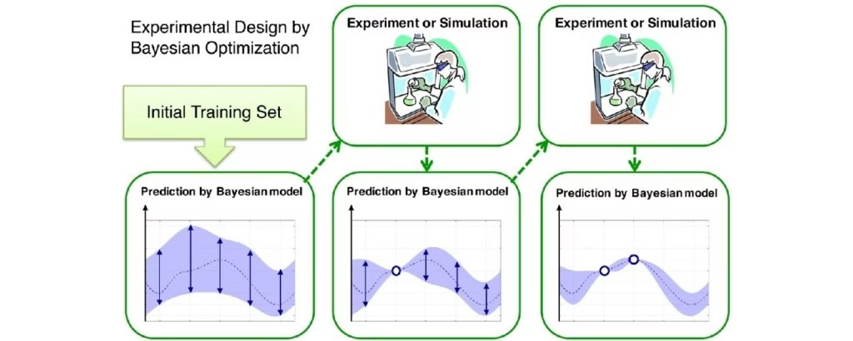

This shouldn’t be surprising because Bayesian optimization is basically a smart search strategy, where the next hyper-parameter is selected in an informed way. It helps reduce the searching time for the optimal hyper-parameter combinations

Advantages:

Lifeguards do play a vital role in the prevention of drownings, but at large busy beaches, they can't always keep track of all the swimmers at all times. That's where Sightbit is designed to come in, as it uses artificial intelligence to catch what lifeguards may miss.

Developed by a startup that originated at Israel's Ben-Gurion University of the Negev, Sightbit incorporates multiple video cameras located along a stretch of beach. These transmit live video to a computer vision system located in a central lifeguard tower, which continuously analyzes the footage utilizing deep learning-based algorithms.